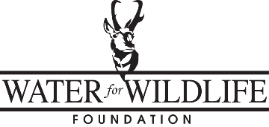

GRANT CLOSEOUT REPORT
Submit completed report at time of final request for reimbursement for project expenses.

PROJECT NAME (as stated on grant application): ______________________________________
WFWF DESIGNATED PROJECT ID#: ______________
WFWF PROJECT APPROVAL DATE: __________________
PROJECT COMPLETION DATE: ___________________
WFWF PROJECT EXPIRATION DATE (3 YEARS POST-APPROVAL DATE): _________________
WFWF FUNDS APPROVED: ___________________
WFWF FUNDS EXPENDED: ___________________
WFWF FUNDS UNEXPENDED: ___________________

MATCHING FUNDS EXPENDED
IDENTIFY PARTNER | IN-KIND SERVICES (value of) | CASH

- SUBMIT COPIES OF ALL INVOICES RELATED TO THE PROJECT

- SUBMIT .JPG DIGITAL PHOTOS OF PROJECT DURING CONSTRUCTION AND AT COMPLETION

- PROJECT UTM COORDINATES: _______________________________

- PROJECT LAT / LONG COORDINATES: _____________________________

- Please provide a short summary of work completed in the space below.

*I verify that all granted WFWF funds were used only for activities / items specified in the grant application.

____________________________________ _____________________
Project Coordinator / Applicant Signature Date

Project Coordinator Information:
Name: |  | Title:
Address: |  | Phone #:
 |  | Email:

WFWF requests that a project status report be completed and emailed to the office by August 1st each year for the life of the project (email: waterforwildlife@wyoming.com). Photos of the project and/or wildlife utilizing the project area are appreciated. Any maintenance completed and known wildlife use should be included in this annual report. Thank you.

